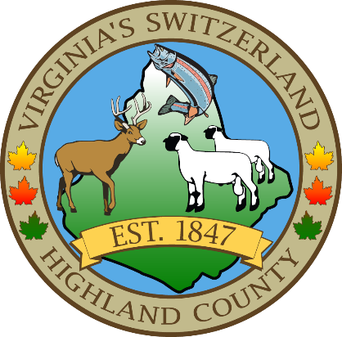
HIGHLAND COUNTY BOARD OF SUPERVISORS
HIGHLAND MODULAR CONFERENCE CENTER
89 HIGHLAND CENTER DRIVE
MONTEREY, VIRGINIA
REGULAR MONTHLY MEETING
DATE: 10/1/2024
TIME: 7:30
- Call to Order
- Approval of Minutes
  - May 7, 2024, May 10, 2024, May 23, 2024, June 4, 2024, July 2, 2024, July 17, 2024, August 6, 2024, August 21, 2024, September 3, 2024
- Public Hearings/Public Appearances
- Public Comments on Agenda Items
- Items for Action, Discussion, Review or Information
  - Overhead Doors Request for EMS building
  - Appointment recommendation to the Local Emergency Planning Committee
- Old Business
  - Code of Ethics
  - HVAC Update for 165 Courthouse Lane
  - Courthouse security project
  - Virginia Association of Counties Conference at the Omni Homestead November 10-12, 2024
- New Business
- County Administrator’s Reports, Requests and Recommendations
  - Reminder of the upcoming Vaccination and Microchip clinic on October 5, 2024. 10am-noon
- Board Comments
- Consent Agenda
- Open Public Comments
- Closed Meeting (as needed)
- Adjourn / Recess

NEXT MEETING(S)

Work Session
HIGHLAND MODULAR CONFERENCE CENTER
MONTEREY, VIRGINIA
DATE: 10/16/2024
TIME:7:30

