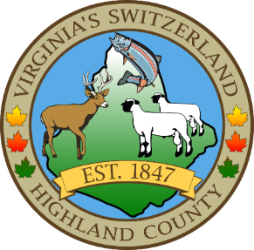
HIGHLAND COUNTY BOARD OF SUPERVISORS
HIGHLAND MODULAR CONFERENCE CENTER
89 HIGHLAND CENTER DRIVE
MONTEREY, VIRGINIA
Work Session Agenda
DATE: 10/16/2024
TIME: 7:30pm

- Call to Order
- Items for Action, Discussion, Review or Information
  - EMS Chief Kosenko and HCVRS President John Montgomery-provide information on the new Quick Response Unit
  - Resolution to Support the Virginia America 250 Commission
- Old Business
- New Business
  - McDowell Water System Operator
- Closed Meeting (as needed)
  - 2.2-3711 (A) (1) Personnel (as needed)
  - 2.2-3711 (A) (3) Property (as needed)
  - 2.2-3711 (A) (5) Prospective Business (as needed)
  - 2.2-3711 (A) (7) Legal – (as needed)
  - 2.2-3711 (A) (8) Legal Advice – (as needed)
  - 2.2-3711 (A) (29) Contract – (as needed)

- Adjourn / Recess

NEXT MEETING(S)
Joint Public Hearing with Planning Commission
HIGHLAND MODULAR CONFERENCE CENTER
MONTEREY, VIRGINIA
DATE: 10/24/2024
TIME: 7:30PM

Regular Monthly Meeting
HIGHLAND MODULAR CONFERENCE CENTER
MONTEREY, VIRGINIA
DATE: WEDNESDAY 11/6/2024
TIME: 7:30PM

Virginia Association of Counties
Annual conference
Omni Homestead
Hot Springs, Virginia
DATE: Sunday 11/9/2024

