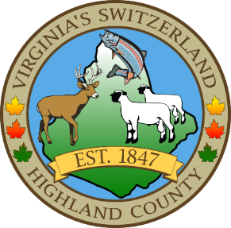
HIGHLAND COUNTY BOARD OF SUPERVISORS
HIGHLAND MODULAR CONFERENCE CENTER
89 HIGHLAND CENTER DRIVE
MONTEREY, VIRGINIA
Work Session Agenda
DATE: 11/20/2024
TIME: 7:30pm

- Call to Order
- Items for Action, Discussion, Review or Information
  - Introduction of New State Park Manager Justin Rexrode
  - Highland County Recreation Commission would like to recommend David Frayer for appointment for a 3-year term expiring December 31, 2027.
  - Request for Proposals for Legal Services
- Old Business
  - Warrant—Accounts Payable for October 2024
  - Adopt a Resolution to set the appropriations for November 2024

- New Business
  - Holiday Bonus Consideration
  - Vote of Support for EMS Chief Kosenko
  - Official apology to Chief Kosenko for the action of a board member
  - Board action to prohibit further attempts by any supervisor to bypass the EMS Chief’s supervisor
- Closed Meeting (as needed)
  - 2.2-3711 (A) (1) Personnel (as needed)
  - 2.2-3711 (A) (3) Property (as needed)
  - 2.2-3711 (A) (5) Prospective Business (as needed)
  - 2.2-3711 (A) (7) Legal – (as needed)
  - 2.2-3711 (A) (8) Legal Advice – (as needed)
  - 2.2-3711 (A) (29) Contract – (as needed)

- Adjourn / Recess

NEXT MEETING(S)

Regular Monthly Meeting
HIGHLAND MODULAR CONFERENCE CENTER
MONTEREY, VIRGINIA
DATE: December 3,2024
TIME: 7:30PM

