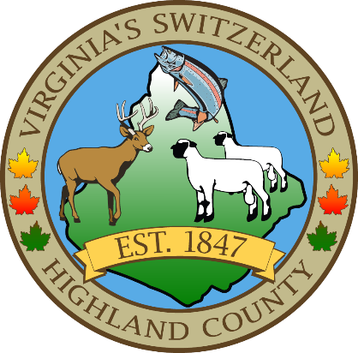
HIGHLAND COUNTY BOARD OF SUPERVISORS
HIGHLAND MODULAR CONFERENCE CENTER
89 Highland Center Drive
MONTEREY, VIRGINIA
REGULAR MONTHLY MEETING
DATE: 8/6/2024
TIME: 7:30

- Call to Order
- Public Hearings/Public Appearances
  - none
- Public Comments on Agenda Items
Items for Action, Discussion, Review or Information
- Old Business
  - Code of Ethics
  - Highland County Public Schools transfer request-Highland County Public Schools is requesting that their budget surplus of $285,286.68 be transferred to the school’s capital account to complete future projects.
  - EMS Chief position
- New Business
  - Signage for Dog Walking and Clean up-the Town of Monterey has placed signs throughout town and would like to know if the county would like to do the same around the walking path.
  - ABC Request—The Highlander- INFORMATION ONLY
  - Bolar Volunteer Rescue Squad DERA status-Bolar Volunteer Rescue Squad would like to switch back to DERA Status
  - ARPA Grant to implement a ballot on demand system for the main Registrar’s office. This would cover the cost of 2 units, training, installation and 3 years of annual fees associated with this equipment. (estimated cost $ 16,230) The county would initially pay the bill and then be reimbursed through the grant.
  - Drought designation/Natural Disaster Designation
- County Administrator’s Reports, Requests and Recommendations
  - Staff Report
- Board Comments
- Consent Agenda
  - Warrant—Accounts Payable for July 2024
  - Adopt a Resolution to set the appropriations for August 2024
- Open Public Comments
- Closed Meeting (as needed)
  - 2.2-3711 (A) (1) Personnel (as needed)
  - 2.2-3711 (A) (3) Property (as needed)
  - 2.2-3711 (A) (5) Prospective Business (as needed)
  - 2.2-3711 (A) (7) Legal – (as needed)
  - 2.2-3711 (A) (8) Legal Advice – (as needed)
  - 2.2-3711 (A) (29) Contract – (as needed)
- Adjourn / Recess

NEXT MEETING(S)

Work Session
HIGHLAND MODULAR CONFERENCE CENTER
MONTEREY, VIRGINIA
DATE: 8/21/2024
TIME: 7:30pm

