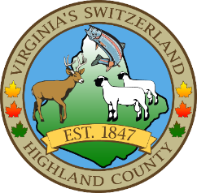
HIGHLAND COUNTY BOARD OF SUPERVISORS
HIGHLAND MODULAR CONFERENCE CENTER
89 HIGHLAND CENTER DRIVE
MONTEREY, VIRGINIA
Work Session Agenda
DATE: 4/28/2025
TIME: 4:00pm

- Call to Order
- Items for Action, Discussion, Review or Information
  - County Budget – Fiscal Year 2025-2026--Adopt a resolution to set the tax rates / levies and adopt the Fiscal Year 2025-202 General Fund (County) Budget
  - Solid Waste Collection and Disposal Budget (Enterprise Fund) –Fiscal Year 2025-2026---Adopt a resolution to set the Enterprise Fees and adopt the Fiscal Year 2025-2026 Solid Waste Collection and Disposal Budget
  - Emergency Medical Services Fund Budget – Fiscal Year 2025-2026--Adopt a resolution for the Fiscal Year 2025-2026 Emergency Medical Services Budget

- Old Business
- New Business
- Closed Meeting (as needed)
- Adjourn / Recess
NEXT MEETING(S)
Regular Monthly Meeting—Public Hearing VDOT 6year plan
Highland County Public School
MONTEREY, VIRGINIA
DATE: May 6, 2025
TIME: 7:30pm

