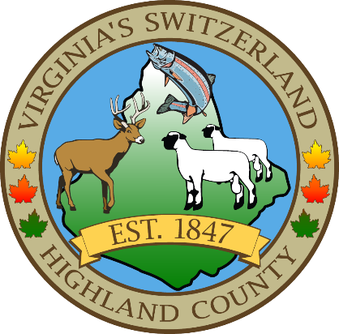
HIGHLAND COUNTY BOARD OF SUPERVISORS
HIGHLAND MODULAR CONFERENCE CENTER
89 HIGHLAND CENTER DRIVE
MONTEREY, VIRGINIA
Work Session Agenda
DATE: March 12, 2025
TIME: 9:00am

- Call to Order
- Items for Action, Discussion, Review or Information
  - Budget Presentations
- Old Business
- New Business
  - Schedule a Joint Public Hearing with the Planning Commission on March 27, 2025, at 7:30pm for a Conditional Use Permit application

- Closed Meeting (as needed)
  - 2.2-3711 (A) (1) Personnel
  - 2.2-3711 (A) (3) Property
  - 2.2-3711 (A) (5) Prospective Business
  - 2.2-3711 (A) (7) Legal
  - 2.2-3711 (A) (8) Legal Advice
  - 2.2-3711 (A) (29) Contract

- Adjourn / Recess

NEXT MEETING(S)
Regular Monthly Meeting
HIGHLAND MODULAR CONFERENCE CENTER
MONTEREY, VIRGINIA
DATE: 3/19/2025
TIME: 6:00pm

