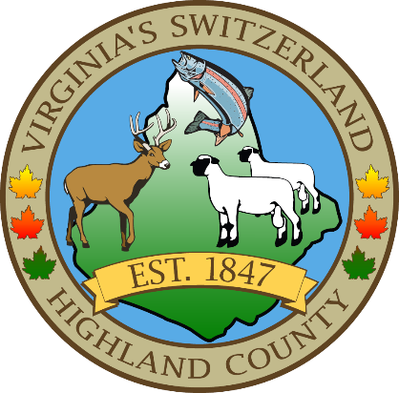
HIGHLAND COUNTY BOARD OF SUPERVISORS
HIGHLAND MODULAR CONFERENCE CENTER
89 HIGHLAND CENTER DRIVE
MONTEREY, VIRGINIA
Work Session Agenda
DATE: 3/19/2025
TIME: 6:00p.m.

- Call to Order
- Public Hearings
  - Highland County Emergency Medical Services Fee Ordinance
    - Staff Report
    - Open Public Hearing—Public Comments
    - Board Comments or Questions
    - Close Public Hearing—Board Action (approve, deny, or table)
- Items for Action, Discussion, Review or Information
  - Projected Revenues for FY 26, Christy Harper, Treasurer
  - Child Services Act Budget Presentation, Beth Armstrong, Child Services Coordinator
  - Budget Review General Fund, Jerri Botkin, County Administrator
- Old Business
  - Emergency Medical Services
    - Emergency Medical Services Buildings
    - Emergency Medical Services Staffing
    - Emergency Medical Services Equipment
    - Emergency Medical Services Ordinance
- New Business
  - Highland County Public Schools 4th quarter appropriation request
- Closed Meeting (as needed)
  - 2.2-3711 (A) (1) Personnel
  - 2.2-3711 (A) (3) Property
  - 2.2-3711 (A) (5) Prospective Business
  - 2.2-3711 (A) (7) Legal
  - 2.2-3711 (A) (8) Legal Advice
  - 2.2-3711 (A) (29) Contract

- Adjourn / Recess
NEXT MEETING(S)
Joint Public Hearing with Planning Commission
HIGHLAND MODULAR CONFERENCE CENTER
MONTEREY, VIRGINIA
DATE: March 27, 2025
TIME: 7:30pm

Regular Monthly Meeting
HIGHLAND MODULAR CONFERENCE CENTER
MONTEREY, VIRGINIA
DATE: April 1, 2025
TIME: 7:30pm

