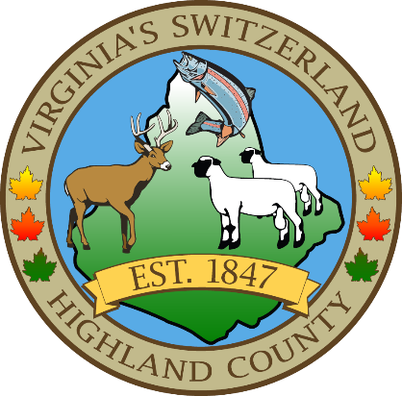
HIGHLAND COUNTY BOARD OF SUPERVISORS
HIGHLAND MODULAR CONFERENCE CENTER
89 HIGHLAND CENTER DRIVE
MONTEREY, VIRGINIA
Work Session Agenda
DATE: 4/16/2025
TIME: 7:30pm

- Call to Order
- Items for Action, Discussion, Review or Information
  - Highland County Public Schools funding obligation, Dr. Drew Maerz, Highland County Superintendent and Jason Wilfong, Chairman Highland County School Board
- Old Business
- New Business
- Closed Meeting (as needed)
- Adjourn / Recess
NEXT MEETING(S)
Regular Monthly Meeting
Highland County Public School
MONTEREY, VIRGINIA
DATE: April 21, 2025
TIME: 6:00pm

