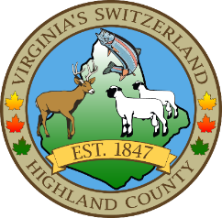
HIGHLAND COUNTY BOARD OF SUPERVISORS
HIGHLAND MODULAR CONFERENCE CENTER
89 HIGHLAND CENTER DRIVE
MONTEREY, VIRGINIA
Work Session Agenda
DATE: 7/16/2025
TIME: 7:30pm

- Call to Order
- Items for Action, Discussion, Review or Information
  - Highland County Chamber of Commerce—closures of Streets for Hands and Harvest Festival-information only
- Old Business
- New Business
  - Consideration of advertisement for tree trimming on the courthouse lawn
  - Approval of downpayment for McDowell Collection site
- Closed Meeting (as needed)
- Adjourn / Recess
NEXT MEETING(S)
Regular Monthly Meeting
Highland County Public School
MONTEREY, VIRGINIA
DATE: August 5, 2025
TIME: 7:30pm

Upcoming items to address or consider
1. Cigarette Tax Ordinance
2. Highland County Erosion and Sediment Control Ordinance-update
3. Transient Occupancy Tax Ordinance-update
4. Agenda items for Joint meeting with Highland County School Board
5. Public Procurement Ordinance-update

