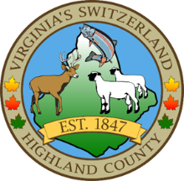
HIGHLAND COUNTY BOARD OF SUPERVISORS
HIGHLAND COUNTY HIGH SCHOOL
241 Myers Moon Road
MONTEREY, VIRGINIA
Public Hearing FY 26 Proposed Budget
DATE: 4/21/2025
TIME: 6:00pm
Call to Order
a. Opening Statement

Public Hearings
General Fund FY26 Proposed budget and Tax rates
Emergency Medical Services Fund FY 26 Proposed Budget and Fees Enterprise Fund FY 26 Proposed Budget and Fees
  - Staff report
  - Open Public Hearing—Public Comments
  - Board Comments
  - Close Public Hearing

NEXT MEETING(S)

Special Meeting—Adoption of Budgets and Tax Rates
HIGHLAND MODULAR CONFERENCE CENTER
MONTEREY, VIRGINIA
DATE: 4/28/2025
TIME: 4pm

Regular Meeting
HIGHLAND MODULAR CONFERENCE CENTER
MONTEREY, VIRGINIA
DATE: 5/6/2025
TIME: 7:30pm

