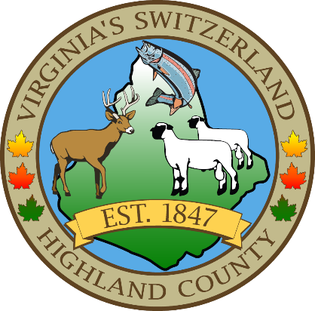

AMERICAN RED CROSS MONTH, 2025
A Proclamation

During American Red Cross Month in March, we celebrate the humanitarian spirit of Highland County and reaffirm our commitment to help ensure no one faces a crisis alone.

Caring for one another is at the heart of our community and exemplified by the people of Highland County, whose simple acts of kindness through the Red Cross provide help and hope in people’s most difficult moments — continuing the lifesaving legacy of Clara Barton, who founded the organization more than 140 years ago to prevent and alleviate human suffering.

Every day, these ordinary individuals lend a helping hand to make an extraordinary difference for neighbors in need — whether it’s providing emergency shelter, food and comfort for families displaced by home fires and other disasters; donating lifesaving blood for cancer patients, accident victims, and people with sickle cell disease and other life-threatening conditions; supporting military members and veterans, along with their families and caregivers, through the unique challenges of service; using vital skills like first aid and CPR to help others survive medical emergencies; or delivering international humanitarian aid and reconnecting loved ones separated by crises around the world.

Their support, volunteerism and generous donations are critical to our community’s resilience. We hereby recognize this month of March in honor of all those who fulfill Clara Barton’s noble words, “You must never think of anything except the need and how to meet it,” and ask everyone to join in this commitment.

NOW, THEREFORE, I, Harry B. Sponaugle, Chairman, of the Highland County Board of Supervisors by virtue of the authority vested in me by the laws of Highland County and the State of Virginia, do hereby proclaim March 2025 as Red Cross Month. I encourage all citizens of Highland County to reach out and support its humanitarian mission.

IN WITNESS WHEREOF, I have hereunto set my hand this15th day of February, in the year of our Lord two thousand twenty-five, and of Highland County, Virginia.

HARRY B. SPONAUGLE, CHAIRMAN Date

