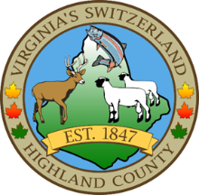
HIGHLAND COUNTY BOARD OF SUPERVISORS
HIGHLAND MODULAR CONFERENCE CENTER
89 HIGHLAND CENTER DRIVE
MONTEREY, VIRGINIA
DATE: May 20, 2026
TIME: 6:00 pm

- Call to Order
- Public Hearings/Public Appearances
  - Public Hearing to Amend the FY 26 Budget
    - Open Public Hearing
    - Staff Report
    - Public Comment
    - Board Comment
    - Action
- Old Business
- New Business
- Closed Meeting (as needed)
- Adjourn / Recess
- Closed Meeting (as needed)
  - 2.2-3711 (A) (1) Personnel (as needed)
  - 2.2-3711 (A) (3) Property (as needed)
  - 2.2-3711 (A) (5) Prospective Business (as needed)
  - 2.2-3711 (A) (7) Legal – (as needed)
  - 2.2-3711 (A) (8) Legal Advice – (as needed)
  - 2.2-3711 (A) (29) Contract – (as needed)

- Adjourn / Recess

NEXT MEETING(S)
Highland County Board of Supervisors
Regular Meeting June 2, 2026
89 Highland Center Drive
Monterey, VA 24465

